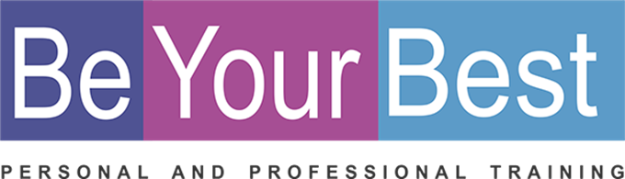
REGISTRATION FORM

PERSONAL DETAILS
Name: |  |  |  |  | Date of Birth:
Tel: |  |  |  |  | E-mail:
Physical Address:

Where did you hear about the BYB Course?: __________________________________________________

Investment in all your relationships
20 Hours Program  10 weeks  2 Hours per week |  | R 225 per hour |  | R 4 500 per person (Including workbook, and certificate)  Only 6 people in a group  On-line
(Please select) ADDED VALUE
You can repeat this course for free any time in the future!
I am a registered service provider so you can submit my account to your medical aid provider and they will reimburse you in accordance with the rules of your medical aid plan for therapeutic services.
Down payment options that will suit your budget.  Please pay on or before last day of the month.  3 payments ( Deposit with registration: 11 Aug 2021 and end of Aug and Sept) |  |  |  |  |  |  |  |  | R 500 deposit  R 2000 per month
BANKING DETAILS
Cheque: | K Badenhorst |  |  |  | Branch: |  | 163 145
Bank: | Nedbank |  |  |  | Acc nr: |  | 163 112 8302
Ref: | Name and Surname |  |  |  | Notification: |  | 0832659388
(Please select) DATES / TIMES / VENUES
 | English |  | 11 Aug – 29 Sept  + 13 Oct + 10 Nov 2021 |  |  | Wednesday  evenings |  | 18:30 - 20:30 |  | On-line  Zoom

