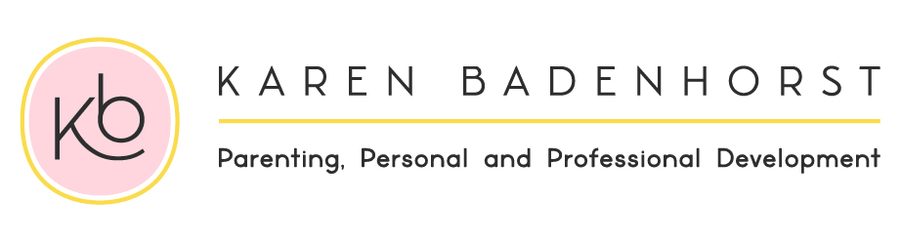
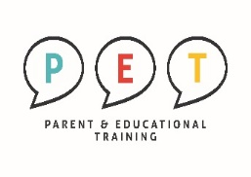
REGISTRATION FORM
PERSONAL DETAILS

Name: Birthdate:

Tel: |  |  |  |  | E-mail:
Physical Address:

Suburb: |  |  |  |  | Study material in Afrikaans or English:
Children’s Names : |  |  |  |  | Ages:
Where did you hear about the PET Course?: __________________________________________________

Your childs’ School name: _______________________________________________________________

Investment in all your relationships

24 Hours Program |  | R145 per hour |  | R 3 500 per person ( R6000 for both parents )  (Including handbook, textbook and certificate)
(Please select) ADDED VALUE

Discount when one payment before or on 1 December 2019. ( R3300 per person / R5800 for couples)

You can repeat this course for free any time in the future!

I am a registered service provider so you can submit my account to your medical aid provider and they will reimburse you in accordance with the rules of your medical aid plan for therapeutic services.

Down payment options that will suit your budget.  Please pay on or before last day of the month.  3 months: |  |  |  |  |  |  |  | R 1 166 per month  R 2 000 for both parents
BANKING DETAILS

Cheque: | K Badenhorst |  |  |  | Branch: |  | 163 145
Bank: | Nedbank |  |  |  | Acc nr: |  | 163 112 8302
Ref: | Name and Surname |  |  |  | Notification: |  | 0832659388
(Please select) DATES / TIMES / VENUES

Afrikaans/English | Tuesday  Mornings  9:00 - 12:00 |  | 28 Jan- 17 March  2020 |  |  | Tygervalley Clinic  Belvedere Office Park  Block B  Pasita street  Rosenpark  Cape Town
English/  Afrikaans | Wednesday Evenings  18:00 - 21:00 |  | 29 Jan – 18 March 2020
