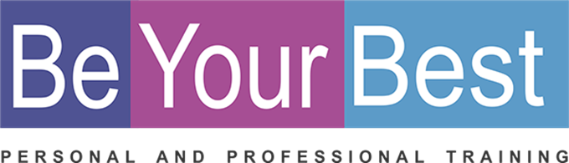
REGISTRATION FORM

PERSONAL DETAILS
Name: |  |  |  |  | Date of Birth:
Tel: |  |  |  |  | E-mail:
Physical Address:

Where did you hear about the BYB Course?: __________________________________________________

Investment in all your relationships
30 Hours Program  10 weeks  3 Hours per week |  | R 150 per hour |  | R 4 500 per person (Including workbook, and certificate)  Only 6 people in a group
(Please select) ADDED VALUE
Discount when cash or one payment before 30 June 2021 ( R4 300 per person )

You can repeat this course for free any time in the future!
I am a registered service provider so you can submit my account to your medical aid provider and they will reimburse you in accordance with the rules of your medical aid plan for therapeutic services.
Down payment options that will suit your budget.  Please pay on or before last day of the month.  3 months ( Deposit with registration: 30 June / 31 July / 31 Aug |  |  |  |  |  |  |  |  | R 1500 per month
BANKING DETAILS
Cheque: | K Badenhorst |  |  |  | Branch: |  | 163 145
Bank: | Nedbank |  |  |  | Acc nr: |  | 163 112 8302
Ref: | Name and Surname |  |  |  | Notification: |  | 0832659388
(Please select) DATES / TIMES / VENUES
Mornings  Evenings | English |  | 29 July-23 Sept 2021+ 28 Okt 2021 |  |  | Thursday  Mornings or evenings |  | 9:00-12:00 OR 18:00 – 21:00 |  | Tyger valley Clinic Belvedere Office Park Block E  Bella Rosa Street  Rosen park  Cape Town

