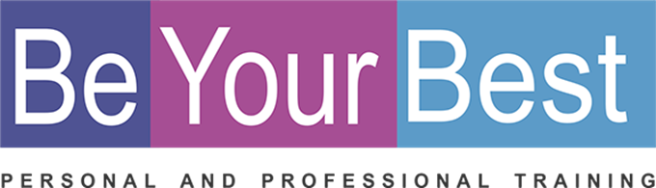
REGISTRATION FORM

PERSONAL DETAILS
Name: |  |  |  |  | Date of Birth:
Tel: |  |  |  |  | E-mail:
Physical Address:

Where did you hear about the BYB Course?: __________________________________________________

Investment in all your relationships
30 Hour Program:  10 weeks  3 hours per week |  | R120,00 per hour |  | R 3600 per person (Including handbook, and certificate)
(Please select) ADDED VALUE
Discount when one payment before 30 Junie 2019. ( R3500 per person )

You can repeat this course for free any time in the future!
I am a registered service provider so you can submit my account to your medical aid provider and they will reimburse you in accordance with the rules of your medical aid plan for therapeutic services.
Down payment options that will suit your budget  Please pay on or before last day of the month.  3 months ( Deposit with registration: 30 June 2019, 31 July, 31 Aug 2018) |  |  |  |  |  |  |  |  | R 1200 per month.  R 360 per week
BANKING DETAILS
Cheque: | K Badenhorst |  |  |  | Branch: |  | 163 145
Bank: | Nedbank |  |  |  | Acc nr: |  | 163 112 8302
Ref: | Name and Surname |  |  |  | Notification: |  | 0832659388
(Please select) DATES / TIMES / VENUES
 | English/Afrikaans |  | 18 July – 12 Sept  2019 |  |  | Thursday  Evenings |  | 18:00-21:00 |  | Northern Suburbs  Karen Badenhorst  (Venue to be confirmed)

